**Problem - 2**

**Student Name: Milan Sharma UID: 23MAI10003**

**Branch: ME – CSE - AIML Section/Group: MAI – 1 (A)**

**Semester: 1st Date of Performance: 18 Sep 2023**

**Subject Name: Artificial Intelligence Subject Code: 23 CSH 621**

1. **Aim of the Experiment :**

Compute the slope of the line of regression obtained while treating Physics as the independent variable. Compute the answer correct to three decimal places.

1. **Objective of the Experiment :**

To Compute the slope of the line of regression obtained while treating Physics as the independent variable. And To Compute the answer correct to three decimal places.

1. **Code :**

def get_regr_slope(x,y):

    xy = [a*b for a, b in zip(x,y)]

    n = len(x)

    x_2 = [a*a for a in x]

    num = n*sum(xy) - sum(x)*sum(y)

    denom = n*sum(x_2) - sum(x)**2

    slope = num/denom

    print("%.3f" % slope)

physics = [15, 12, 8, 8, 7, 7, 7, 6, 5, 3]

history = [10, 25, 17, 11, 13, 17, 20, 13, 9, 15]

get_regr_slope(physics, history)

1. **Output:**

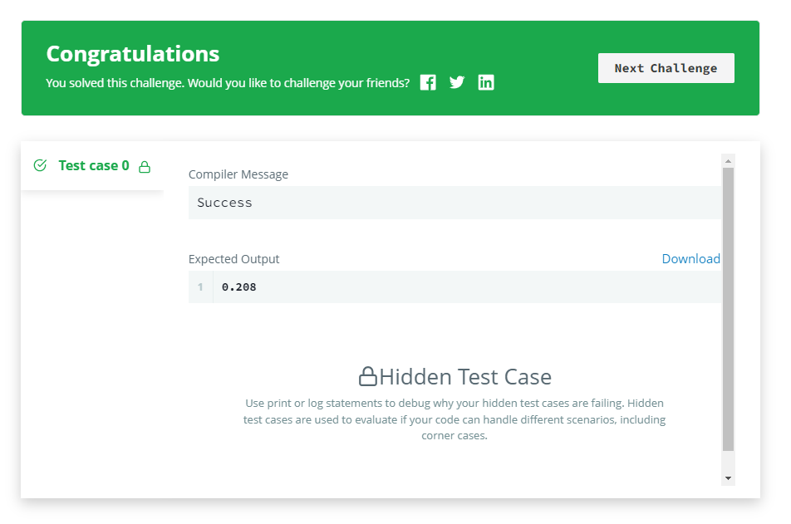

**Learning outcomes (What I have learnt):**

1. **Learned about numpy and pandas libraries.**
2. **Learned to use map function**
3. **Learned how to solve slope problems.**